HHuman Rights Act Impact Assessment Proforma

This proforma will help you to articulate any human rights issues in the policy/proposal that you are working on. It is necessary for you to have read the OFMDFM guidance on human rights entitled “Get in on the Act; a practical guide to the Human Rights Act for public authorities in Northern Ireland” before completing this proforma.

If the policy/proposal is relevant to some rights but does not interfere with or limit them, your assessment must be signed off by a Senior Responsible Officer (Grade 7, equivalent or above). If you find that it does interfere with or limit one or more of the Convention rights, and your Senior Responsible Officer agrees, you must seek legal advice, even if it is considered that the interference or limitation is justified.

This proforma is available at w ww.ofmdfmni.gov.uk/human-rights If you fill in the
form electronically, there is no restriction as to the amount you can type in each box.

Your answers in the rest of this proforma will help you draft a clearer note to your legal advisor.

PPolicy title and aims

Please state the title and objective of the policy/proposal you are working on.
This is an assessment of the potential Human Rights Impact of the duties arising from Section 1 of the Period Products (Free Provision) Act (Northern Ireland) 2022.

Section 1(1) of the Act requires that "period products are obtainable free of charge (in accordance with arrangements established and maintained by the Department) by all persons who need to use them".

Section 1(2) provides that the free period products provided under these arrangements "are to be sufficient products to meet the person’s needs while in Northern Ireland".

The Act requires that the arrangements to established and maintained to ensure provision of free period products are in place on or before 12 May 2024.

RRights which the policy/proposal engage

Go through each of the rights detailed in the table below. For each one consider whether the policy/proposal engages the right, i.e. how the policy/proposal you are working on could involve the right. Explain how the right is engaged

Please note that the rights have been abbreviated so you should see the relevant Article in the Guide referred to above for the full title and explanation of the right.

Right | Yes/No | Explanation
Article 2 Right to life | No | Not relevant
Article 3 Prohibition of torture, inhuman and degrading treatment | No | Not relevant
Article 4 Prohibition of slavery and forced labour | No | Not relevant
Article 5  Right to liberty | No | Not relevant
Article 6  Right to a fair trial | No | Not relevant

Right | Yes/No | Explanation
Article 7  No punishment without law | No | Not relevant
Article 8  Right to respect for private and family life | Yes | Article 8 is engaged only insofar as the Act requires that free period products are made available to all persons who need to use them in a way that respects their privacy, dignity and confidentiality.
Article 9  Freedom of thought conscience and religion | No | Article 9 is engaged only insofar as the products to be made available will ensure respect for freedom of religion.
Article 10 Freedom of expression | No | Not relevant
Article 11 Freedom of assembly and association | No | Not relevant
Article 12  Right to marry and found a family | No | Not relevant
Article 14 Prohibition of discrimination | Yes | Article 14 is engaged only insofar as the Act requires that sufficient period products are obtainable free of charge by all persons who need to use them to meet that person’s needs while in Northern Ireland. The Act requires that this includes provision for period products to be obtainable by another person on behalf of the person who needs to use them.

Right | Yes/No | Explanation
Protocol 1, Article 1 Right to property | No | Protocol 1, Article 1 is potentially engaged only insofar as the Act requires that sufficient period products are obtainable free of charge by all persons who need to use them to meet that person’s needs while in Northern Ireland.
Protocol 1, Article 2 Right to education | No | Protocol 1, Article 2 is engaged only insofar as the Act requires that sufficient period products are obtainable free of charge by all persons who need to use them to meet that person’s needs while in Northern Ireland.
Protocol 1, Article 3 Right to free elections | No | Not relevant

If you have answered yes to any of these questions you must complete the rest of the proforma. If you have answered no to all of the questions, you may proceed to Question 9.

Rights which the policy/proposal interferes with or limits

Will the policy/proposal interfere with or limit any of the rights you identified as being engaged? If so, explain how the right is interfered with or limited.

You should note that interference could be a negative impact on a right or a failure to take positive action where this is required under the Article in question. For further guidance on which Articles require positive action, please consult the Guide.

Article | Interfered with or limited?  Yes/No | What is the interference/limitation?
8, 9, 14, Protocol 1  Articles 1 and 2 | No

Those affected by the interference/limitation

Identify who could be affected by the interference or limitation, e.g. sections of society or people with certain beliefs or opinions, and explain how they could be affected.

It will help in identifying interferences or limitations to think about all the people who could be affected and be seen as a victim within the Human Rights Act.

Who could be affected? | How could they be affected?
N/A | N/A

LLegal basis for interference/limitation

Is there a law which allows you to interfere with or limit the rights identified in Question 4?

Any interference with or limitation on a Convention right must have a legal basis. You therefore need to establish whether there is a law which allows the proposed interference or limitation.

You may need legal advice to clarify this.

Relevant legislation:
N/A

Alternatively, the policy/proposal may involve the creation of a new law which allows for the interference or limitation. If this is the case, please detail and explain in the box below:
N/A

PPurpose of the policy/proposal

Even if the interference or limitation in the policy/proposal is according to the law, there are further conditions which must be met. The purpose of the policy/proposal must pursue a legitimate aim or fall under one of the specific exceptions in the Article in question.

Consider each of the Articles which the policy/proposal will interfere with or limit, and for each one specify the exception or legitimate aim which allows the interference or limitation and explain why.

If you are unsure of the exceptions or legitimate aims which are applicable for the rights interfered with or limited by the policy/proposal you are working on, you should refer to the text of the Convention and the Guide.

Article | Exception / Limitation | Explanation
N/A

NNecessary in a democratic society

Articles 8, 9, 10 and 11 specify that interferences or limitations must be necessary in a democratic society. If the policy/proposal interferes with or limits one of these rights, detail in the table below how the right is necessary in a democratic society i.e. does it fulfil a pressing social need?

You may need to speak to the Senior Responsible Officer for clarification of this

Article affected | Explain why it is necessary in a democratic society
N/A

PProportionality

Any interference with or limitation on a Convention right must be proportionate,
i.e. the policy/proposal must interfere with or limit a right no more than is absolutely necessary to achieve its aims. For each Article which the policy/proposal interferes with or limits, explain how the interference or limitation is proportionate.

For further information on proportionality please consult the Guide.

Article affected | Explain why the interference / limitation is proportionate
N/A

AArticle 14 equality issues

Even if it does not interfere with or limit a right or freedom, could the policy/proposal result in people being treated differently in relation to any of the Convention rights? Article 14 does not allow discrimination in the exercise of any of the other Convention rights.

For further information on Article 14, please refer to the relevant pages in the Guide

Convention Article affected | How are people treated differently? | Is this justifiable?
N/A

You should now have a clearer view about the policy/proposal and the possibility of it engaging or interfering with Convention rights and freedoms.

Please ensure the proforma is also signed by your Senior Responsible Officer and if there is any possible interference or limitation refer to your legal advisor for further action and advice.

Please tick the statement that applies, and sign below.

  - The policy/proposal does not engage any Convention rights.

  - The policy/proposal does engage one or more of the Convention rights, but does not interfere with or limit it/them.

  - The policy/proposal interferes with or limits one or more Convention rights and legal advice is being sought.

Countersign, hold copy with policy papers and refer to your legal advisor

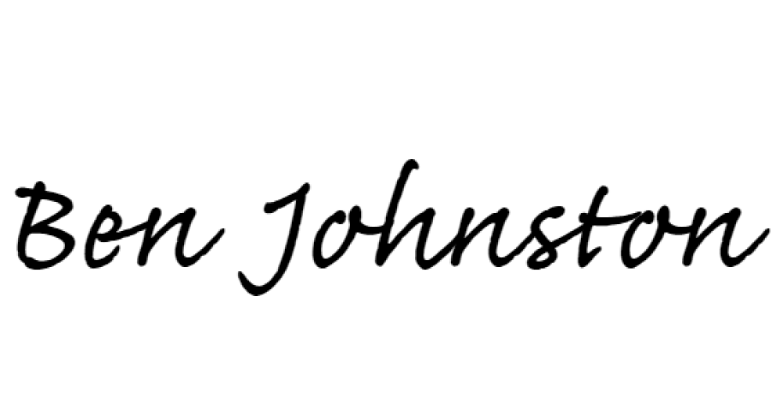
Signed by _ (Official)

Date 16/06/2023
Grade DP _

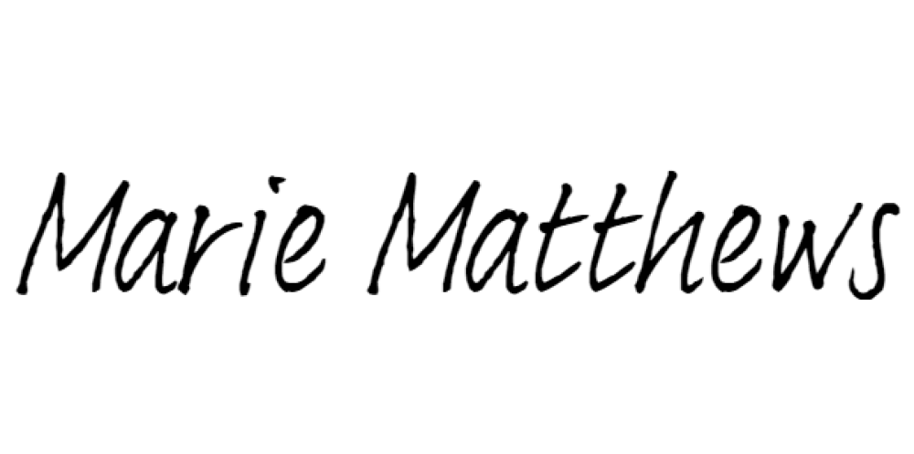
Signed by _ (Senior Responsible Officer)

Date
16/06/2023
Grade
Grade 7 _

Human Rights Act Referral to Legal Services Proforma

FAO: _
_

From: _
_
_ _

Please see the attached Human Rights Act Impact Assessment Proforma for the following proposal/policy.
Title and Objective of Policy/Proposal:

I have identified the following rights as being interfered with/limited by this policy/proposal.

I would be grateful for your advice on this matter. All relevant papers are attached.

Your contact in this Department is:
Name:
Address: _

Tel: _ Email: _

