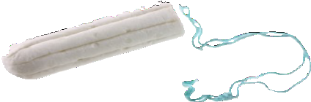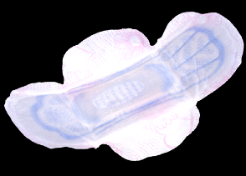

Free period products in Northern Ireland

Tell us what you think

Easy Read

Easy Read
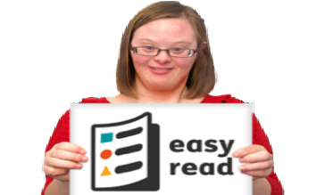This is an Easy Read version of some information. It may not include all of the information but it will tell you about the important parts.

This Easy Read booklet uses easier words and pictures. You may still want help to read it.

Some words are in bold - this means the writing is thicker and darker.

These are words that some people will find hard. When you see a bold word, we will explain it in the next sentence.

This word
means….

Blue and underlined words show links to websites and email addresses. You can click on these links on a computer.

links

What is in this booklet
About this booklet 4
Why do people need free period products? 5
Tell us what you think 7
Before you start 9
Questions for you to answer 10
What happens next? 29
Issues and complaints 31

About this booklet

The Executive Office is a Department in the Northern Ireland Civil Service.

The Executive Office helps the government to make good decisions for the people that live here.

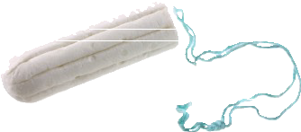We want to make sure people can get free period products.

Free
Period products are items people use when they are on their period, like pads and tampons.

We would like to know what people think about getting free period products.
Free

Please read the information in this booklet and answer the questions to tell us what you think.

Why do people need free period products?

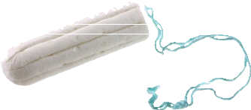Period products are very important.
People need them to be able to deal with their periods.

Not being able to get period products can lead to bad health and wellbeing.

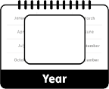The Period Products Act is a law that says we must make sure people can get free period products from May 2024.
Period Products Act
May
2024

What we want
We want to make sure:

- It is easy for everyone to pick up free period products.

- People can pick up free period products in ways that do not make
them feel embarrassed or uncomfortable.

- 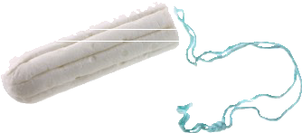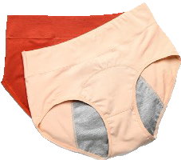There are different types of period products that people can get for
free.

- People can pick up free period products for someone else.

Tell us what you think

We want to know what you think about:

- How people should be able to get free period products.

- 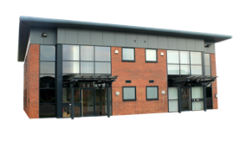Where people should be able to pick up free period products.

- 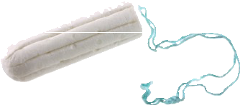What types of period products should be free.

We want to hear from as many people as we can.
Tell us what you think by answering the questions in this booklet.

Any information you give us will be kept safe.

Safe

We follow the law when we collect and keep personal information.

The Law

Before you start
Before you start, please tell us who you are answering these questions for:

Yourself
An organisation

If you are answering these questions for an organisation please tell us its name:

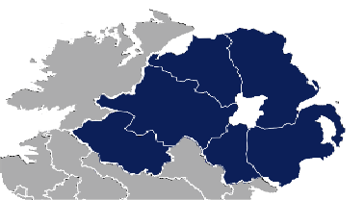Questions for you to answer
Question 1: Please tell us the local Council for the area that you live in.

Antrim and Newtownabbey Borough Council

Ards and North Down Borough Council

Armagh City, Banbridge and Craigavon Borough Council

Belfast City Council

Causeway Coast and Glens Borough Council

Derry City and Strabane District Council

10

Fermanagh and Omagh District Council

Lisburn and Castlereagh City Council

Mid and East Antrim Borough Council

Mid Ulster District Council

Newry, Mourne and Down District Council

Other - please tell us below:

11

Jasmin Baines 16 High Street Sunnyfield BT48 6XY
Question 2: Please tell us the first 4 letters and numbers of your postcode:

Question 3: Please tell us which of these answers describes you:
You can tick as many answers as you like.

I use period products at the moment

I will need to use period products in the future

I am a woman with a family member who needs period products

I am a man with a family member who needs period products

12

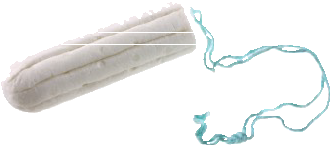
Question 4: Would you get free period products if you could?
Free
Yes
No

I know someone who is not a family member that needs period products

I do not want to answer this question

Other - please describe below:

13

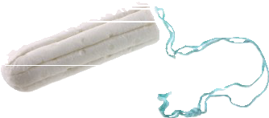Question 5: What might stop you from getting free period products?
You can tick as many answers as you like.

Being too embarrassed to pick them up

Not knowing where to pick them up from

Not being able to get to the place where I would pick them up from
If you have ticked this answer, please tell us a little more about why you would not be able to get there:

Religious reasons
If you have ticked this answer please tell us a little more about your religious reasons:

14

I would rather buy my own choice of period products

Nothing would stop me

Other - please describe below:

Question 6: Who would you be okay with picking up free period products for?
You can tick as many answers as you like.

Myself

Another person who lives in my household

Another person who does not live in my household

No other person

Other - please tell us below:

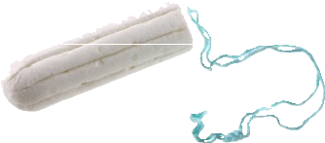Question 7: What period products do you think people should be able to get for free?
You can tick as many answers as you like.

Pads

Tampons with applicators

Tampons without applicators

Panty liners

Reusable period pants
Reusable means that you can wash them and use them more than once.

Reusable menstrual cups

Reusable pads

Reusable panty liners

17

Other - please tell us below:

Question 8: Please tell us how important reusable period products are to you.

Very important
A little important
Not very important
Not important at all

Question 9: Reusable period products are harder to get than non-reusable ones.
People may have to give details about how to contact them if they want reusable products.

Would you be okay with giving details about how to contact you?

Yes

No

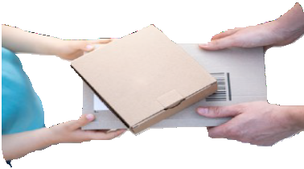
Question 10: How do you think people should get free period products?
You can tick as many answers as you like.

Pick them up in person from a set place

Delivered to their home

Using an online service - they would order products online and then pick them up from a set place

Other - please describe below:

Question 11: Where do you think people should be able to pick free period products up from?
You can tick as many answers as you like.

Public libraries

Public buildings
If you have ticked this answer, please tell us what public buildings:

Museums

Local community places
If you have ticked this answer, please tell us what local community places:

Other - please describe below:

21

Question 12: We want people to be able to pick up free period products in ways that do not make them feel embarrassed or uncomfortable.

Where in a building would you feel most comfortable picking up free period products?
You can tick as many answers as you like.

In the toilets

In the reception area

In a private room

On a display stand

I don’t mind

Other - please tell us below:

22

Question 13: How do you think that we should let people know where they can pick up free period products from?
You can tick as many answers as you like.

NI Direct website

An app on mobile phones that shows people places they can pick up products

Local media, like newspapers and radio

Social media

Posters and leaflets inside the places where people can pick up products

Other - please describe below:

Question 14: If there was an app on your phone that showed you where you can pick up products, how likely would you be to use this app?
Very likely
Slightly likely
Not very likely
Not likely at all

Question 15: Some groups might have certain period product needs.
Please tell us any comments you have about how we should make sure we are meeting everyone’s needs:

Question 16: We have checked to see what effect our plans for free period products have on:

- Making sure everyone is equal.

- People who live in the countryside.

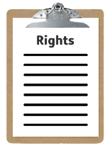

Safe
- People’s human rights.
Human rights are the things that every person should have or be able to do, by law.

- Keeping people’s information safe.

26

We found that providing free period products would have no seriously bad effects on any of these.

Please tell us if you have any comments about this:

Question 17: Please tell us any further comments you have about getting free period products:

What happens next?

Thank you for answering these questions.

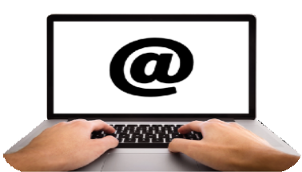Please now send your answers to us by either:

  - Email: period.products@executiveoffice-
ni.gov.uk

  - Post:
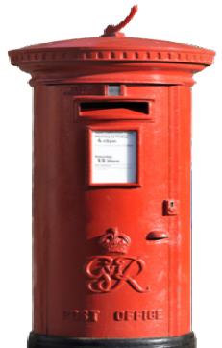Equality Policy & Legislation Team The Executive Office
Room A5.1
5th Floor Castle Buildings Stormont Estate
BELFAST BT4 3SR

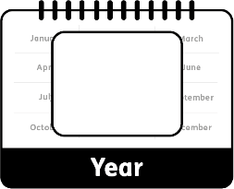You should send your answers to us by 18 September 2023.
18
September

We will look at everyone’s answers and share what we find out on our website.

Issues and complaints
If you are not happy with the way that we are asking people what they think, then you can make a complaint.

You can make a complaint by:
  - 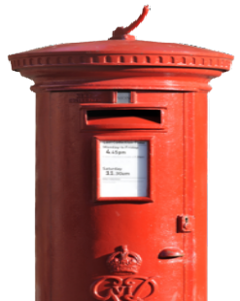Writing a letter and posting it to: Machinery of Government
Room SD03 Stormont Castle BELFAST
BT4 3TT

  - Sending an email to: info@executiveoffice-ni.gov.uk

  - 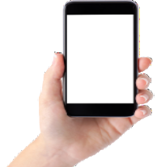Calling: 028 9037 8055

This Easy Read booklet was produced by easy-read-online.co.uk
The booklet includes images licensed from Photosymbols & Shutterstock.

