**The Department of Justice Logo - in English, Irish and Ulster Scots.  The Department's web address is also provided.**

**Public Consultation on Increasing the Minimum Age of Criminal Responsibility in Northern Ireland from 10 Years to 14 Years**

**October 2022**

**A photograph of the Justice Minister, Naomi Long MLA.**

**Ministerial Foreword**

The age at which a child should be held criminally liable is an emotive and often controversial issue and one which has long divided opinion. The current minimum age of criminal responsibility (MACR) in Northern Ireland is 10 years old. Below this age, a child cannot be prosecuted or held liable for any criminal acts; above this age, they can face the full force of the law. Our MACR is the lowest in Europe and substantially lower than 14 years, which the UN Committee on the Rights of the Child considers to be the very youngest age that a child should be held criminally liable.

I have long been a supporter for change in this area and have been very clear about my wish to increase MACR to bring Northern Ireland into line with international standards. My view, which is supported by many organisations representing children’s rights and by the research evidence, is that children under 14 years should not be drawn into the youth justice system, as early contact with the justice system often has a negative long-term impact on children’s lives and patterns of offending behaviour.

I recognise that the youth justice system has to balance many needs, particularly those of victims and communities, alongside the welfare and future life-chances of children who have offended; however, it is in the best interests of victims and communities that we work with children who offend, to find the root cause of their behaviour and ensure they receive the support they require in order to turn their lives around.

My Department’s new Strategic Framework for Youth Justice included a commitment that we would seek the views of the public on this important issue. I encourage everyone with an interest to respond to this consultation - your views could have an impact on the future outcomes of many children in Northern Ireland.

**Naomi Long MLA**

**Department of Justice**

**Introduction and background to the consultation**

1. The minimum age of criminal responsibility (MACR) is the lowest age at which a person can be arrested and charged with committing a crime. In Northern Ireland, the MACR is currently set at 10 years of age, which is one of the lowest in Europe, and also one of the lowest in the world.
2. The Minister of Justice has consistently indicated her support for an increase to MACR as this would allow Northern Ireland to comply with the UN Committee on the Rights of the Child recommendation that the minimum age of criminal responsibility for Member States should be at least 14 years of age and preferably higher.
3. Minister Long’s support for an increase to MACR was further outlined in her Department’s *Strategic Framework for Youth Justice,* published in March 2022. The Action Plan that accompanied the Framework included a commitment to carry out a consultation to seek the views of the public on increasing MACR in Northern Ireland to 14 years old within the first year following publication.
4. The outcome of this consultation will be published in due course and will be used to inform the debate over future changes to MACR in Northern Ireland.

**Background**

1. The minimum age at which a child can be charged with a crime remains unchanged since the 1960s when, following a recommendation from a report into the youth justice system, it was increased from 8 years to 10 years in England, Wales and Northern Ireland. The landscape for youth justice has undergone considerable change in the intervening years, with a shift in focus from punishment to rehabilitation, however, the current MACR does not reflect this.
2. The UN Convention on the Rights of the Child (UNCRC) is an international human rights treaty which sets out the civil, political, economic, social, health and cultural rights of children. Article 40(3) of the Convention requires member states to set a minimum age of criminal responsibility but does not specify the age. However, following ratification of the Convention, over 50 member states raised the minimum age in their jurisdictions which has resulted in the most common MACR internationally being 14 years.
3. In reports issued by the UN Committee on the Rights of the Child in response to periodic examinations on the UK’s compliance with the Convention, the Committee has repeatedly highlighted our low MACR and recommended that it be raised “in accordance with acceptable international standards”. Furthermore, the Committee’s 2019 report[1] urged all member states to take account of recent scientific evidence and to raise their minimum age accordingly, to at least 14 years.

**Consideration of MACR in Northern Ireland**

1. MACR was considered as part of two major examinations of the youth justice system in Northern Ireland which were carried out in the previous decade. The first was undertaken by an independent team of experts in 2010 and became known as the Youth Justice Review (YJR). This review examined how children were processed at all stages of the criminal justice system to ensure that our youth justice system was complying with international obligations and best practice. In its report, published in September 2011, the Review Team formally recommended that MACR in Northern Ireland be raised immediately to 12, with consideration given to raising it to 14 subsequent to a review.
2. The recommendation on MACR was included as part of a wider consultation on all of the YJR recommendations. The outcome of this consultation showed considerable support, particularly from children’s sector organisations, for increasing MACR in Northern Ireland.
3. The issue of MACR was also considered as part of a cross-departmental Scoping Study in 2015. This study found in favour of raising MACR to at least 12 on the basis that it would not only deliver on the specific, as yet unmet, YJR recommendation but it would assist Northern Ireland in complying with the UN Committee on the Rights of the Child and other international standards. Furthermore, it would effectively deliver on the Department’s overarching aim to improve outcomes for children by keeping them out of the justice system for as long as possible and removing the burden of a criminal record with the associated stigma of being a ‘young offender’.
4. Whilst efforts have been made by Justice Ministers, most recently by Minister Long, to secure cross-Executive agreement to raise the minimum age of criminal responsibility, there has been insufficient support to progress this issue to date. The responses to this consultation could, therefore, be instrumental in determining whether the Department has sufficient support to bring about a change in the legislation.

**Current position in other jurisdictions**

1. In England and Wales, as with Northern Ireland, the MACR is 10 years old. The UK government has faced pressure from the UN Committee on the Rights of the Child as well as other groups representing children’s rights and has also been subject to a recommendation from a Select Commons Committee in Westminster to review MACR. Despite this, there has been no movement in terms of legislating to increase MACR in England or in Wales.
2. In June 2019, the Age of Criminal Responsibility (Scotland) Act was introduced and fully commenced on 17 December 2021. This Act raised MACR to 12 years, meaning no child in Scotland under the age of 12 can be found guilty of a criminal act. Children under this age who display risk-taking or offending behaviours will instead be dealt with through the welfare-orientated Children’s Hearing System.
3. In exceptional circumstances, appropriate safeguards and powers are in place for Police Scotland to investigate harmful behaviour in children under 12. The Scottish Government has included a provision requiring MACR to be reviewed three years after the age increase has been introduced. Given that the new legislation has been in place for less than a year, it is too early to evaluate its impact on the youth justice system.
4. Ireland has also seen an increase in MACR from 7 to 12 following the commencement of their children’s legislation enacted in 2006. Provision has been made for exceptional cases, with criminal responsibility for the most serious offences being set at 10 years of age.
5. Even greater variance in MACR is evident across Europe where children are not held criminally liable until the age of 14 years (Germany, Italy, and Spain), 15 years (Denmark, Sweden, Norway, and Finland), or 18 years (Belgium and Luxembourg). The only other European country which has a MACR as low as 10, outside the UK, is Switzerland. Details of the current MACR in each European country can be found at **Annex A**.

**Youth Offending in Northern Ireland**

1. Changes in youth justice policies and operational practices in recent years have seen a significant reduction in the overall number of children entering the formal youth justice system, including prosecutions at court. To provide context, five out of every one thousand children in Northern Ireland will have some level of involvement with the Youth Justice Agency and less than one in one thousand will be held in youth custody.
2. The table in **Annex B** provides a breakdown of all court prosecutions and out of court (diversionary) disposals for children, by age, for the years 2011-2021. From this, we can see that the number of children entering the formal system more than halved during this period, going from 5,764 in 2011 to 2,382 in 2021.
3. The information in this table allows us to assess the potential impact of an increase in MACR to various age points, including the proposed new age of 14 years. It does this by providing an indication of the number of children it would impact. Across all age groups, but in particular for younger children, the current policy is very much focused on diverting young people from formal prosecution wherever possible and this is reflected in the data.
4. In considering the potential impact of an increase in MACR to 14 years of age, we can see that in 2021, there were 99 children under this age processed through the court system. This is out of a total of 1,182 prosecutions for that year, which represents 8.4% of all youth prosecutions. Whilst this figure fluctuates from year to year, the average over the last decade for under 14s has been 7.1% of all prosecutions.
5. Turning to diversionary disposals, in 2021 the total number of children aged under 14 who were handed down a formal diversionary disposal was 229, which represents 19.1% of all diversionary disposals for children that year. This means in total there were 328 under 14s dealt with by the formal justice system in 2021, or 13.8% of total disposals. Therefore raising MACR to 14, whilst only removing a relatively small amount of children from the formal justice system, would nevertheless have a significant positive impact on their lives and future prospects. This is explored further in the next section.

**The case for change**

1. When taken in the context of other age limits, MACR is considerably lower than the age at which children can legally assume other responsibilities such as sexual consent, marriage, the purchase of tobacco/lottery tickets and the ability to vote. It is also in stark contrast to the civil justice provisions made in the Mental Capacity Act (NI) 2016 which provide safeguards and protections for vulnerable persons aged 16 and over who lack capacity to make decisions about their health, care, finances and personal welfare. These provisions apply to those aged 16 and over as the policy view was that no child below this age was mature enough to make such decisions; responsibility instead rests with the parents or guardians in these cases. In contrast, the criminal justice system considers a child to be mature enough at 10 to take criminal responsibility for their actions.
2. Research into the development of the brain during adolescence, and the implications this has in relation to risk-taking and the understanding of longer-term consequences, supports non-criminal justice interventions for the small number of children aged under 14 who offend.
3. The current MACR was set at a time when limited research regarding adolescent brain development had been undertaken, however a 2011 Royal Society report[2] showed that changes in important neural circuits underpinning behaviour continue until at least 20 years of age. This, and the imbalance between the developmental stages of the prefrontal cortex and the amygdala, can explain the often heightened emotions and risk-taking behaviours which are common to adolescents, supporting the case for increasing MACR. Furthermore, research[3] using MRI scanning has proven that the period of adolescence (from age 10–19 years) represents significant neurodevelopmental and behavioural changes.
4. In terms of the long-term impact which contact with the justice system has on the lives of children, research demonstrates that if children are criminalised from a young age they are more likely to be drawn further and deeper into the criminal justice system. A detailed longitudinal study[4], involving a cohort of 4,300 children in Scotland, concluded that the deeper children penetrate the youth justice system, the more ‘damaged’ they are likely to become and the less likely they are to stop offending and grow out of crime. This, in turn, has negative consequences for society as a whole.
5. A further study[5] carried out in the US which involved over 1,200 adolescent boys looked at whether formal processing following an offence led to worse outcomes for adolescents than informal processing. The results indicated that formal processing of an adolescent charged for the first time with a relatively moderate offence, caused more harm than good. Furthermore, those formally processed were more likely to be re-arrested, incarcerated and engaged in more violence.

**The impact of increasing MACR**

1. Often it is the most troubled and vulnerable children who find themselves deeply entrenched in the justice system. For many of these children, an earlier intervention to address underlying issues and provide support for change, could have prevented them from becoming involved in the criminal justice system and saved them from the stigmatisation and other life-long consequences which often follow. As the research has shown, if we act to criminalise young children, we only increase the likelihood that they will go on to re-offend and potentially become persistent offenders.
2. In saying that, however, victims and communities affected by anti-social or criminal behaviour carried out by children, have a right to redress. The question is not *whether* children should be held accountable but *how* that should be achieved to maximum effect, and whether the solution requires the full weight of the criminal justice system to be effective. There is a significant difference between saying that a child aged 10 “knows right from wrong”, and saying that they should be criminalised for their behaviour.
3. Any change in policy should be made with the best interests of the child as central to the decision. By increasing MACR, we would be consciously ensuring that offending is treated as one aspect of a child’s behaviour which must be addressed. It would not be considered in isolation of all the child’s other needs, whether that includes, for example, a safe and supportive environment in which to grow up or support for mental health needs.
4. Those countries which have adopted a higher MACR, such as Norway and Denmark, where the minimum age is 15 years, have embraced a welfare-orientated approach to tackling offending behaviour by children. In practice, this involves the child becoming the responsibility of social services with the focus being on supporting the child and his/her family to address the underlying issues which the offending behaviour displays. Not only does this allow for the child’s often complex needs to be met, but it also provides an opportunity for them to repair harm they have caused and re-engage in normal society.
5. In Northern Ireland, Children’s Diversion Forums have recently been rolled out across the region. The overall aim of these Forums is to help divert children from the formal justice system through more coordinated identification, information sharing, assessment, intervention and review of children involved in low level offending and/or antisocial behaviour. Panels are chaired and administered by the Youth Justice Agency, and also include representatives from PSNI, Social Services and the Education Authority. Partner organisations can take appropriate referrals from the panel, or provide the conduit between the children and his/her family and other services provided by the statutory, voluntary and/or community sectors. We believe these forums, or a similar approach, could provide an appropriate framework within which problem behaviour displayed by children who fall under the new MACR could be addressed.
6. The main concern raised by those who are opposed to increasing MACR is how we then address serious violent crimes, such as murder, when they are committed by a child. Rare, high profile murder cases involving children have been much publicised in the media and this has contributed to a culture of fear and the adoption of a tougher stance on crimes by children, meaning that many children have ended up paying a high price as a result of the actions of a tiny minority.
7. Examples such as the tragic James Bulger case have been cited as a reason not to increase MACR in Northern Ireland. This is despite the fact that, to date, we have never had a case where a child under 14 years of age has been sentenced for murder. That said, we cannot definitively say that it could never happen.
8. In considering whether MACR should be increased, it is worth taking account of the view that policy and legislation should not be based on exceptional cases. Instead, any significant changes should reflect the reality of what is happening in practice; the best interests of the child; and our statutory responsibilities and international commitments.
9. However, in acknowledgement of the above concern and to address a scenario whereby a child under the MACR committed an extremely serious offence, one option could be to introduce an exception for certain grave offences. While this option would not be endorsed by the United Nations Committee on the Rights of the Child, which stated that it was “*concerned about practises that permit the use of a lower minimum age of criminal responsibility in cases where, for example, the child is accused of committing a serious offence”[6],* it would replicate the approach adopted by the Irish Government and may help to address concerns which the public and politicians have around serious crimes.

**Conclusion**

1. The figures set out in the table in Annex B demonstrate that an increase in MACR to 14 years, while having a considerable impact on the lives of the individuals involved, would not have a significant impact on the overall numbers of children in contact with youth justice system.
2. The relatively low numbers of children involved has often been cited as a reason **not** to change MACR. However, the Justice Minister and all those in support of children’s rights are confident that we should increase MACR because it is the right thing to do. Raising the age of criminal responsibility in law sends out a clear message that our children who offend need and deserve our support, guidance and help – not merely criminalisation and punishment.
3. Not only would increasing MACR bring Northern Ireland into line with international standards and best practice, but it would also reinforce the Department’s commitment to delivering on the Youth Justice Review recommendations, the 2015 Scoping Study and the recently published Strategic Framework for Youth Justice.
4. The views of the public will be crucial in determining whether there is sufficient support to help the Department to secure an increase in MACR. A number of options have been proposed for the way forward, and we would be grateful if you could take the time to give us your views.

**Table comparing the minimum age of criminal responsibility in European countries**

| Country | MACR | Country | MACR |
| --- | --- | --- | --- |
| Albania | 14 | Luxembourg | 18 |
| Andorra | 12 | Macedonia | 14 |
| Armenia | 16 | Malta | 14 |
| Austria | 14 | Moldova | 16 |
| Azerbaijan | 16 | Monaco | 13 |
| Belarus | 16 | Montenegro | 14 |
| Belgium | 18 | Netherlands | 12 |
| Bosnia & Herzegovina | 14 | Northern Ireland | 10 |
| Bulgaria | 14 | Norway | 15 |
| Croatia | 14 | Poland | 15 |
| Cyprus | 14 | Portugal | 16 |
| Czech Republic | 15 | Romania | 14 |
| Denmark | 15 | Russian Federation | 14 |
| England | 10 | San Marino | 12 |
| Estonia | 14 | Scotland | 12 |
| Finland | 15 | Serbia | 14 |
| France | 13 | Slovakia | 14 |
| Georgia | 14 | Slovenia | 14 |
| Germany | 14 | Spain | 14 |
| Greece | 15 | Sweden | 15 |
| Hungary | 14 | Switzerland | 10 |
| Iceland | 15 | Turkey | 12 |
| Ireland | 12 | Ukraine | 16 |
| Italy | 14 | Wales | 10 |
| Latvia | 14 |  |  |
| Liechtenstein | 14 |  |  |
| Lithuania | 14 |  |  |

Source: Child Rights International Network, (2019) Minimum Age of Criminal Responsibility in Europe, available at: <https://archive.crin.org/en/home/ages/europe.html>

**Prosecutions at court and out of court disposals**

**(for children aged between 10 and 17)**

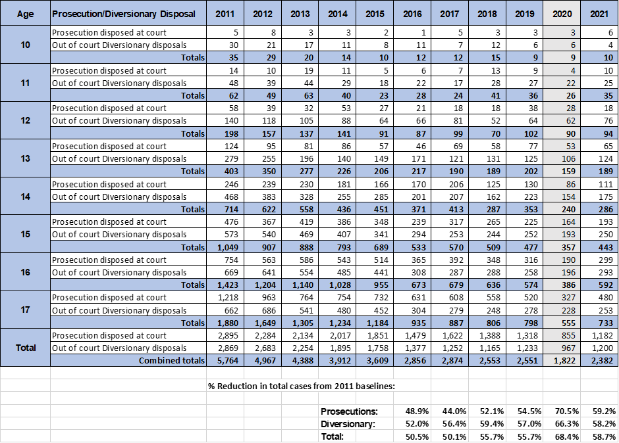

**Notes:**

1. Age is in relation to age at offence date.
2. Figures for prosecutions at court relate to case disposed at court whether the outcome was a conviction or not. Some may have resulted in a not guilty verdict.
3. Figures for diversionary disposals include cautions, informed warnings, community based restorative justice outcomes and Youth Conference Plans.
4. 2020 figures (shaded column) were significantly impacted by Covid and are not therefore fully representative.

1. United Nations (2019) – Committee on the Rights of the Child: General comment No. 24 (2019) on children’s rights in the child justice system - CRC/C/GC/24
2. Brain Waves Module 4 – Neuroscience and the Law – December 2011 – Royal Society
3. Sowell, E.R., Thompson, P.M., Holmes, C.J., Jernigan, T.L. & Toga, A.W. (1999). In vivo evidence for post-adolescent brain maturation in frontal and striatal regions. Nat. Neurosci. 2, 859–61; Giedd, J. N. & Rapoport, J. L. (2010). Structural MRI of pediatric brain development: what have we learned and where are we going? Neuron 67, 728–34
4. McAra, L. and McVie, S. (2007) “Youth Justice? The impact of system contact on patterns of desistance from off ending” – European Journal of Criminology, 4(3), 315-45
5. Cauffman, E. Beardslee, J. Fine, A. Frick, P. J.and Steinberg, L. (2020) -Crossroads in juvenile justice: The impact of initial processing decision on youth 5 years after first arrest
6. United Nations (2019) – Committee on the Rights of the Child: General comment No. 24 (2019) on children’s rights in the child justice system - CRC/C/GC/24