Committing Crime:
Why Your Age Matters

What’s it all about?
In Northern Ireland, once you reach the age of 10 years old you can be arrested and charged with a crime if you break the law. This is what is known as the Minimum Age of Criminal Responsibility, or MACR for short.

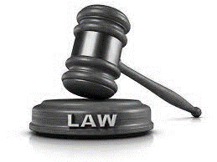

Northern Ireland’s MACR is one of the lowest in Europe, and lots of experts believe it should be much higher. In fact, the United Nations Committee on the Rights of the Child says that 14 years of age should be the very youngest age that a child should be held criminally liable.

We agree with the experts and would like to change our MACR to 14 years.
But we know that people have lots of different views on this. That’s why we are asking everyone to tell us what they think.

Why do we want to change?
Most children here will never come into contact with the youth justice system, but for those that do, we know that being thought of as a ‘criminal’ and having a criminal record can have a negative impact on their lives for a long time.

Studies show early contact with the justice system causes more harm than good, and that if children are dealt with by the justice system at an early age, it can mean their offending gets worse rather than better.

Science has also proved that the way children think and behave is very different to adults because their brains are still developing. Children often don’t think through the consequences of what they say and do, and take more risks than adults would. All of these things can mean children get involved in offending unintentionally, not because they are criminals or bad people.

Think about some of the other age limits here. Children can’t buy a lottery ticket until they are 16, can’t learn to drive until they are 17, and can’t vote or buy cigarettes until they are 18. But people think that it’s ok for a 10 year old to be arrested and maybe even held in custody. What do you think?

What would we do instead?
When we talk about raising MACR, people sometimes think it means letting children ‘get away’ with bad behaviour. That’s not our plan; even young children can understand right from wrong and that actions can have consequences. But we don’t think that those consequences should potentially ruin their lives or their futures.

Instead, we think that helping children who are involved in crime to live better lives, and providing them with support if they have a problem, will help not only them, but everyone affected by their behaviour – including victims, families and communities.

What impact could it have?
Thankfully, we don’t see too many young children in the justice system. So if we raised MACR to 14, it would not have a big impact on numbers.

Let’s look at some figures to show what we mean:
- In 2020, there were approx. 195,498 children aged between 10 and 17 in Northern Ireland.
- In 2021, there were total of 2,382 children dealt with by the justice system, either through a diversion or at court, because they had committed a crime.
- Of these, only 328 children were aged under 14.

These numbers have been falling for years, because children are being helped better and earlier. So we can see that raising MACR to 14 would only affect a small number of children, but it could have a big impact on their lives.

What about really serious crimes?
Over the years, there has been a small number of really serious crimes committed by young children in other countries, including murder, and people often use these as a reason not to increase MACR here in NI. We don’t think that this tiny number of exceptional cases should be a reason to keep MACR at 10 for everyone, but we wanted to see what you thought about that.

What happens now?
Thank you for reading this paper. On the last page, we have asked some questions to get your views on MACR and what you think should happen. We would really appreciate it if you could answer the questions and then send your answers to us.

You can do this by email: macrviews@justice-ni.gov.uk

Or you can write to us at:

Reducing Offending Division
Room 306
Dundonald House
Upper Newtownards Road
Belfast
BT4 3SU

Please send in your replies before the closing date of 23 December 2022. The answers we get will help us to decide what to do about MACR in the future.

Thank you for your help.

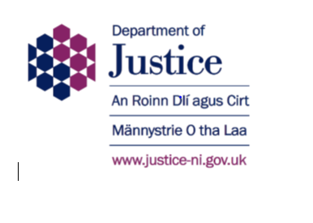

You don’t have to provide the following information if you don’t want to. If you do, it will only be used for our records, and will not be published anywhere or made available to anyone.

Name:

Email address:

I am:

Over 18 years old Under 18 years old

Question 1
The UN Committee on the Rights of the Child says that 14 years of age should be the very youngest age for the minimum age of criminal responsibility (MACR). Our MACR in Northern Ireland is 10 years of age.

Do you agree that MACR should be raised from 10 to 14 years here?

Yes No

Question 2
If you said “No” to Question 1, what age do you think MACR should be set at here in NI?

10 years

12 years
16 years
18 years

Question 3
You only need to answer this if you said MACR should stay at 10 years in Question 2.

Would you think about changing your mind and raising MACR here if we agreed that it would stay at 10 for children who committed very serious crimes, like murder?

Yes No

Question 4
You only need to answer this if you said “yes” to Question 3.

What do you think MACR should be increased to for everyone else?

12 years

14 years
16 years
18 years

