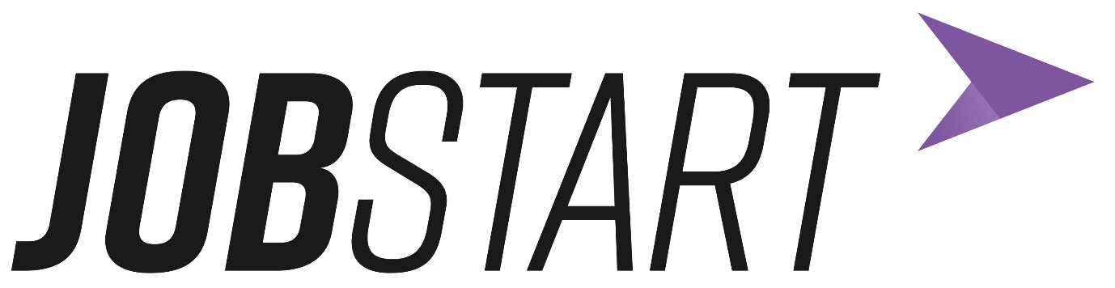

Jobstart Privacy Notice

What is a Privacy Notice?
This notice will tell you why we need to collect personal information about you, how we will do it and what we will use it for. It also lets you know what rights you have regarding your information and how to complain if you aren’t happy with what we do.

What is UKGDPR?
GDPR are new regulations that came into force on 25th May 2018 in all European Countries. GDPR is short for General Data Protection Regulations. (When the United Kingdom (UK) left the European Union these regulations became known as UK GDPR). These regulations outline how someone’s personal data should be collected and processed. It gives certain rights to a person to enable them to control how, and when, their personal information can be used. In this notice, you will see different names or terms used that you may not be familiar with, such as:
Data Controller: A controller is a person (or group of people, like Ulster Supported Employment Ltd or the Department for Communities) who decides what information to collect, how it is collected, how it is used and how it is stored. They are in charge of the information.
Data Processor: A processor is a person who collects the information and processes it according to the Controllers instructions.
Data Protection Officer: This person makes sure we do everything the law says. Personal data: This means any information that can be used to identify someone, such as your address or date of birth.
The Department for Communities is the data controller of the personal information you give us – we look at how and why your information is collected and used.
Sometimes the Department for Communities has to give your information to other people, such as the organisations who deliver our Scheme, but it will only pass on your information to do our job or when the law says that we have to. When your information is given to someone else, they must look after it and keep it safe. This is done using a Data Sharing Agreement between the organisations which clearly states how your information should be used and stored.
Why do we collect and use your information?
By taking part in the JobStart Scheme, we will need to collect information about you. This information will be used to make sure you are provided with all the necessary support to get the most from the scheme It also helps us to make sure our scheme is as good as it can be and is easily accessed by a wide range of different young people.
The information gathered is only used for the delivery of the JobStart Scheme. Without this information we would find it difficult to deliver the scheme to you.
When we’ve collected your information, here’s how we use it:
• To support your learning
• To monitor and report on your progress
• To provide appropriate support
• To protect your welfare
• To assess the quality of our service
• To comply with the law regarding data sharing

What information do we collect?
The categories of information that the Department collects, holds and shares include the following:
Your personal information
This is things like your name and address.
Your characteristics
This means information about you, like where you’re from, what is your age and things like that.
Your attendance information
We will record your start and end date of your time on the JobStart Scheme.
Your assessment information
We collect information, using a survey form, on things like:
- if your confidence and motivation have increased,
- if you feel your employability skills and occupational skills have improved, etc.
Some of your personal information
We will use a secure code system to record if you have a disability, are leaving care, or have been involved with the Department of Justice, this information is only recorded to make sure that you receive an extended JobStart opportunity.
Your special needs
We collect information that helps us make it easier for you to take part in the JobStart Scheme, for example any reasonable adjustments you might need or if you need to reduce your hours.
Behavioural information
We record any incidents that have happened during your time on the JobStart Scheme, why they happened and what action was taken.
Photography and filming
Using photographs and film of you counts as processing your personal data. Before we take any photographs, or include you in a film, we will ask you to give permission for us to take and use pictures/footage of you. We might use your pictures in reports, presentations or on the Department’s website, for example.

How long do you keep my information?
We don’t keep it forever, only as long as we need it to help us do the thing we needed it for. Information will be kept for the duration of your involvement in JobStart Scheme and for 14 months after the Scheme finishes. We have a policy in the Department that tells us when to keep it and when to destroy it.
What happens to my information?
Your information will be collected by one of our delivery partners and/or your JobStart employer. They will do this using a Start Notification Form.
Your information is held safely by the delivery partner and will only be shared with the
Department for Communities.
Do I have to give you my information?
Do you want to take part? You can decide . You will need to provide information about you to take part in the Job Start Scheme. If you don’t want to provide the information, that’s your choice. However, without the necessary information you will be unable to take part in the JobStart Scheme.
What rights do I have?
You have the right to:
• Be told how we use your information
• Access to your information
• Ask us to change information you think is wrong
• Ask us to remove information when it’s not needed anymore
• Ask us to only use your information in certain ways, in specific circumstances
• Tell us you don’t want your information to be processed However, in such circumstances the delivery partner Ulster Supported Employment Ltd would need to consider whether you can take part in the programme
If you’re worried about how we get and use your information, you can speak to us or our partner organisations, who will be able to answer any questions that you have. If you want to speak to somebody outside of the JobStart Scheme you can call the people who look after information, called the Information Commissioner’s Office (ICO) on telephone number 0303 123 1113, email ICO (ico.org.uk/ global/contact-us/email/) or contact them via Live Chat (ico.org.uk/global/contact-us/).

How to contact our Data Protection Officer?
Data Controller Name: Department for Communities
Department for Communities Address:
Information Management Branch
5th Floor 9 Lanyon Place
Belfast
BT1 3LP
Telephone: (028) 9082 9197
Email: DPO@communities-ni.gsi.gov.uk
Data Protection Officer Name: Karen McMullan
Department for Communities Address:
Information Management Branch
Room2.2
9 Lanyon Place
Belfast
BT1 3LP
Telephone: (028) 9082 9200
Email: dpo@communities-ni.gsi.gov.uk

